**Dalton & Gayles Village Hall.**

***COMING TO A VILLAGE HALL NEAR YOU, SOON !!***

**“DADS”. DALTON AMATEUR DRAMATIC SOCIETY**

Present

**PANTO 2019.**

**“Beauty & The Beast”**

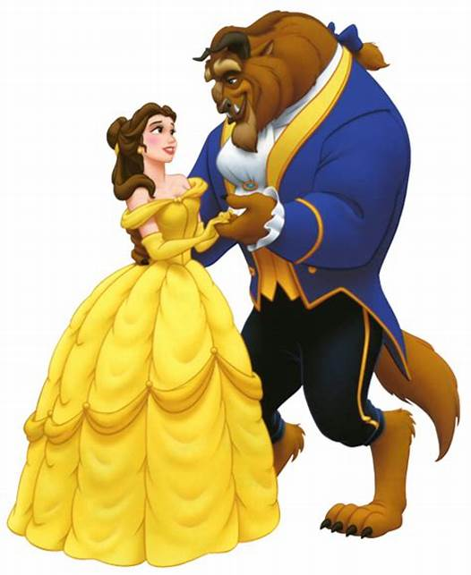

**Thursday FEBRUARY 28th, Friday MARCH 1st & Saturday MARCH 2nd. 2019.**

**Nightly @ 7.30pm.**

**Ticket Prices: Adults £6.00 U14’s £4.00**

Book from Pam Brathwaite.

Tel: 01748 825057 or 07854 287096

*One…. Not to be missed!!!*