NEWSHAM CHRISTMAS
MARKET

SATURDAY 10th NOVEMBER 11am – 2pm

WITH GRAND CHRISTMAS DRAW at 1.30pm

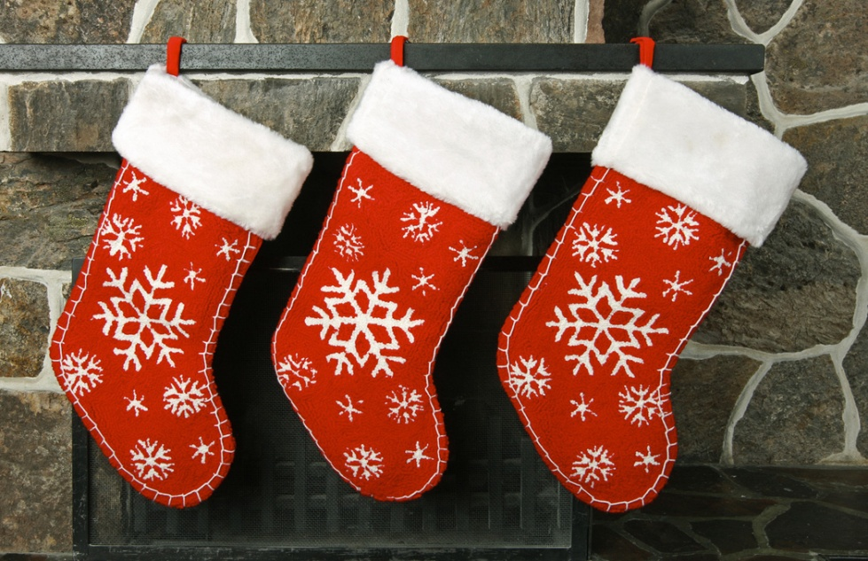
Local crafts and Christmas goods
TEA COFFEE AND MINCE PIES
HOT TURKEY ROLLS * HOMEMADE SOUP

Admission by donation to village hall funds
For more information contact Rose rrtkdavies@btinternet.com

