[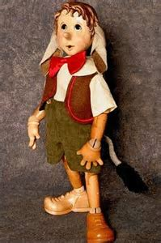](https://www.bing.com/images/search?q=&view=detailv2&iss=rec&FORM=INRECC&ft=GGF&it=IMG&lft=UF&st=TPD&dt=IMG&fvid=0&recfirst=0&reccount=35&lids=pinocchio&id=A13C3B62E027D58D074A1A13459D8C92BD3D52D9&ccid=DueM7bU7&thid=OIP.DueM7bU7WITeiSS42wkktADHEs&first=1000&selectedIndex=1021)

**DAD’s (Dalton & Gayles Amateur Dramatics Society) proudly present**

**At Dalton & Gayles Village Hall.**

**For THREE performances, only @ 7.30 p.m., each evening,**

on THURSDAY 1st, FRIDAY 2nd and SATURDAY 3rd, MARCH 2018

Based on a script by Joshua Dixon. www.lazybeescripts.co.uk

Tickets: Adults: £ 6.00. Children (under 14): £ 4.00

AVAILABLE NOW

Contact: Pam Brathwaite. Tel: 01748 825057

**“Pinocchio.”**

Dalton & Gayles Village Hall: Registered Charity 1081889

**Their Pantomime version of**